1. Write a Pandas program to select the distinct department id from

employees file.

Code:

import pandas as pd

data = {

'DEPARTMENT_ID': [10,20,30,40,50,60,70,80,90,100,110,120,130,140,150,160,170,180,190,200,210,220,230,240, 250,260,270],

'DEPARTMENT_NAME': ['Administration','Marketing','Purchasing','Human Resources',

'Shipping','IT','PublicRelations','Sales','Executive',

'Finance','Accounting','Treasury','Corporate Tax',

'ControlAnd Credit','ShareholderServices','Benefits',

'Manufacturing','Construction','Contracting','Operations',

'IT Support','NOC','ITHelpdesk','Government Sales',

'Retail Sales','Recruiting','Payroll']

}

df = pd.DataFrame(data)

distinct_dept_ids = df['DEPARTMENT_ID'].drop_duplicates()

print("Distinct Department IDs:")

print(distinct_dept_ids.tolist())

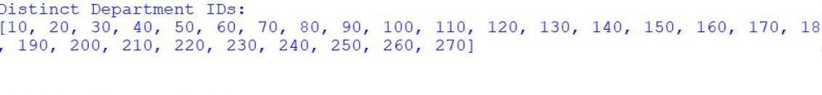
Output

2. Write a Pandas program to display the IDs of employees who have

done two or more jobs in the past.

Code:

import pandas as pd

data = {

'EMPLOYEE_ID': [102,101,101,201,114,122,200,176,176,200],

'JOB_ID': ['IT_PROG','AC_ACCOUNT','AC_MGR','MK_REP',

'ST_CLERK','ST_CLERK','AD_ASST',

'SA_REP','SA_MAN','AC_ACCOUNT']

}

df = pd.DataFrame(data)

job_count = df.groupby('EMPLOYEE_ID')['JOB_ID'].count()

result = job_count[job_count>= 2]

print("Employees who have done two or more jobs:")

print(result.index.tolist())

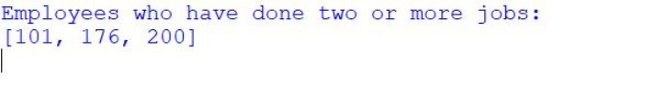
Output

3. Write a Pandas program to display the details of jobs in descending

sequence on job title.

Code:

import pandas as pd

data = {

'JOB_ID':['AD_PRES','AD_VP','AD_ASST','FI_MGR','FI_ACCOUNT',

'AC_MGR','AC_ACCOUNT','SA_MAN','SA_REP','PU_MAN',

'PU_CLERK','ST_MAN','ST_CLERK','SH_CLERK',

'IT_PROG','MK_MAN','MK_REP','HR_REP','PR_REP'],

'JOB_TITLE':['President','Administration Vice President',

'AdministrationAssistant','Finance Manager',

'Accountant','Accounting Manager',

'PublicAccountant','Sales Manager',

'Sales Representative','Purchasing Manager',

'Purchasing Clerk','Stock Manager',

'Stock Clerk','Shipping Clerk',

'Programmer','Marketing Manager',

'Marketing Representative',

'Human Resources Representative',

'Public Relations Representative']

}

df = pd.DataFrame(data)

result = df.sort_values(by='JOB_TITLE', ascending=False)

print(result)

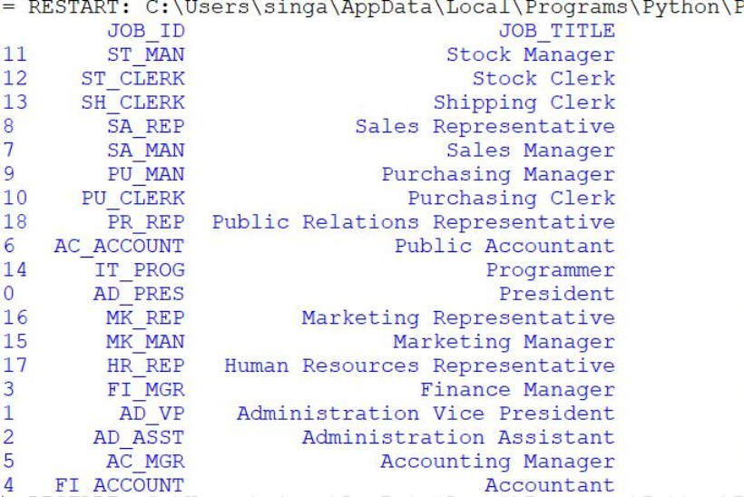
Output:

